WELCOME PACK

Welcome to Poppyfield Equestrian Riding School.
We are a British Horse Society (BHS) approved Riding School and Livery Yard. This pack includes forms for completion and useful information.
We offer you a very warm welcome and if you have any further questions that are not covered by the pack, please do not hesitate to get in touch.

MEET THE TEAM
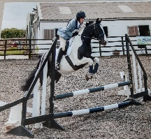
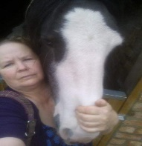
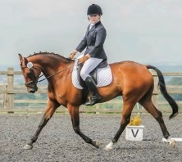
Charlotte ‘Nails’
Staff

Emma Brewster
Staff

Chloe Astill
Staff
International Event Rider

Mandy
Staff

Jo Morton
Proprietor
Staff

Clare Ackroyd
Staff

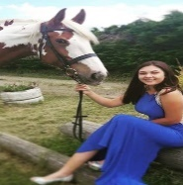
Demi
Staff

MEET THE HORSES & PONIES

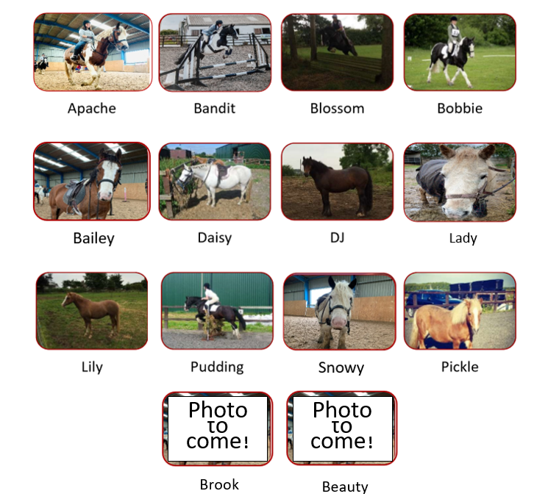

For safety, clients are requested not to feed any of the horses or ponies without an instructor or member of staff present.

FACILITIES
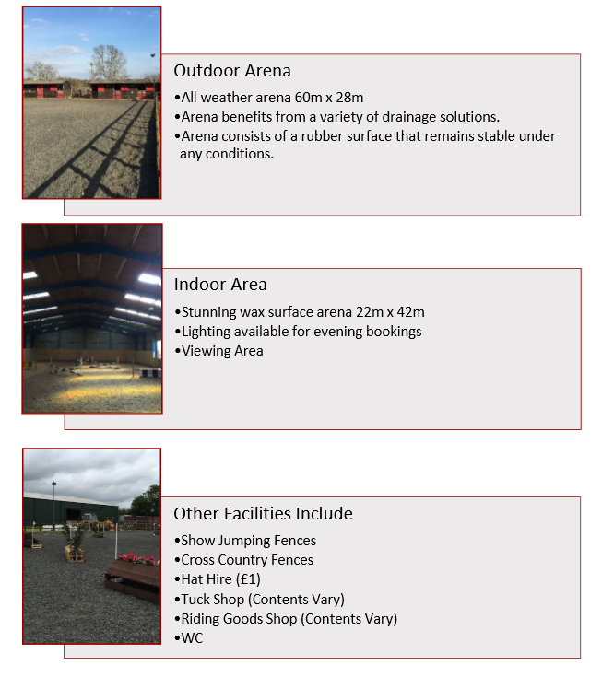

Lesson Prices and Saturday Pony Club
Group Lessons
1 Hour - £20.00
30 Minutes - £15.00

Semi-Private Lessons (Up to 4 Riders)
30 Minutes - £24.00
45 Minutes - £35.00

Private Lessons
15 Minutes - £15.00*
30 Minutes - £28.00
45 Minutes - £37.00

*For age 2 -4 year olds and must be accompanied whilst riding by a parent or guardian.

Saturday Pony Club
Run every week on a Saturday, at a cost of £10.00 per child, between 10:00am and 4:00pm for ages 4 and upwards. "Earn a Badge" day held once a month.
Before you can participate in Saturday Pony Club you will need to be a Pony Club Member. Membership is available online on the pony club website.

All Riders must have completed and handed in a "Rider Registration Form" prior to riding (included at the end of this pack).

RULES OF THE SCHOOL
- Riders must wait for permission to enter from the instructor.
- Keep the gate/door closed unless entering or leaving the school.
- Announce if you are going to open the gate/door as some horses might spook at the noise. Give riders a chance to prepare.
- Riders should line their horses up in the centre of the school when mounting and each horse should be kept a safe distance apart and well in from the outside track.
- When moving off, riders should check that the way ahead is clear and should have a basic plan of where they are going next.
- When working around the school, riders should pass left hand to left hand. This means that riders working on the right rein (with their right hand nearest to the centre of the school) should give way to those riders working on the left rein. To do this they should move onto the inside track and away from the wall.
- Keep a minimum distance of a horse’s length between you and the horse in front.
- No rider should halt on the track as a rider approaching from behind may not be able to stop in time. The exception to this is if you are told to do so by the instructor.
- Riders should halt in a safe place in the centre of the school and should always check that no-one is behind them before they do so.
- Riders should not walk on the track if others are moving at faster paces. The riders in the faster paces have right of way on the track.
- Riders should at all times be aware of the other horses and riders in the school and should be looking where they are going so they are less likely to collide.
- Riders should at all times behave sensibly and proceed with caution.
- If a rider falls off and a horse gets loose, all riders should halt in the centre of the school.
- All equipment (jumps, poles etc.) must be put away when no longer required, you have completed your ride or at the end of each day.
- The school must be poo-picked on completion of your ride and at the end of each day.

CUSTOMER FEEDBACK QUESTIONNAIRE
We value your feedback; please take a minute to complete the form below (tick all that apply). Thank you.
- How often do you/your child ride at Poppyfields?
First Visit Monthly Fortnightly Weekly More than Once a Week

- What activities have you/your child participated in today?
Private Lesson Semi-Private Lesson Group Lesson Pony Club

- How would you rate your experience today?
Excellent Good Average Poor Other (please specify)

- Do you consider the lesson/activity to be:
Excellent value for money A fair price for the activity Poor value for money Other (please specify)

- How would you rate the standard of facilities?
Excellent Good Average Poor Other (please specify)

- How satisfied are you with the standard of teaching given by your instructor?
Excellent Good Average Poor Other (please specify)

7. In addition to the holiday activities we already run, what else would you like to see in the future?

FREQUENTLY ASKED QUESTIONS

Here are a few answers to questions which we are asked on a regular basis. We hope you find it helpful. Please remember we are here to assist you and will be more than happy to answer your questions and guide you through the world of horses.
I am thinking about booking a Horse-riding lesson. How do I go about it? Please contact us or call into Poppyfield Equestrian Riding School. You cannot book or cancel lessons by e-mail. There is an answer-phone service, if you would like to leave a message we will try to get back to you as soon as possible. We are open 7 days a week.
Can I come and have a look around? Yes, we welcome site visits but please contact us first so that we can ensure there is a member of the team available to show you around and answer any queries that you may have.
Are you insured? Yes, we have Public and Employers Liability Insurance however we always recommend that riders take out their own personal accident insurance. The British Horse Society have a policy which is very good value but please check exactly what this covers you for as you would for any other insurance.
I am a bit worried about falling off. Will I be safe? We consider ourselves to be very safety conscious however you should be aware that horseriding is recognised as a RISK sport. Your choice to ride is voluntary. If you choose to ride, the chances are that at some time or another you are going to fall off but in the majority of cases you will be unhurt and back on your feet before you know what happened. We take every precaution to minimize the associated risks however it is also important that you understand that horses are large sensitive animals who can behave unpredictably at any time so please take care, and accept that accidents do happen. The bottom line is, if you really don’t want to fall off, don’t get on.
How do I pay? Payment is required in full at the time of booking-in and can be made by cash or cheque. We do not accept debit or credit cards.
What happens if I need to cancel my lesson? We require a minimum of 24 hours' notice for any cancellation for any reason whatsoever.
Will my lesson still go ahead if the weather is bad? Yes, horse-riding is an outdoor activity and therefore we aim to ride in all but exceptional weathers. Riding in the indoor school is not guaranteed so please ensure that you wear suitable clothes at all times.
How long before my lesson do I need to arrive? If it is your first time with us please arrive at least 15 minutes before your lesson to enable one of our team to welcome you and so that you may complete one of our Rider Registration Forms before you ride. If you are a regular rider 5 minutes is sufficient however please be aware that we run a fairly punctual timetable and if you are late you may lose valuable lesson time.
What is a Rider Registration Form? This is a mandatory document which must be completed (by an adult 18yrs.) before you ride or participates in any activities at Poppyfield Equestrian Riding School. It asks for personal details, people who can be contacted in an emergency, medical history including any previous injuries you may have incurred horse related or not and doctors details. We also need to know about your riding ability/experience.
Will I have the same Instructor each time? Yes, we always try to maintain continuity with Instructors however you do need to take into consideration factors such as sickness, holiday and so forth. If you would simply like to try another Instructor you are more than welcome to do so.

Can I bring my dog to Poppyfield Equestrian Riding School? We would prefer that you didn't as we have had instances of unruly dogs.
Can Parents watch? Yes of course, you are very welcome to watch but please remember that it is in your Child’s interest to build a bond with their Instructor and children sometimes behave differently when parents are watching. You must also resist the temptation of talking to your child while the lesson is in progress. Please do not attempt to teach your child from the side-lines as it is very disconcerting for all concerned.
Where will I ride? We have both a large outdoor and indoor school.
Is there a weight limit for the horses? Each horse has a weight limit that alters as the horse gets older or less fit. Although riding a horse that is not up to your weight may not cause it an injury at the time, repeated use will cause back and leg problems. All riders complete an enrolment form on their first lesson and are asked their height and weight. At the moment, the upper weight limit is 14 ½ stone
What sort of horses do you have? We have horses and ponies of various shapes, sizes and types who will accommodate most levels of rider.
I am interested in learning about caring for horses as well as riding them. Is this something that you offer? Yes we offer courses for both adults and children in various formats, please contact us for details.
Can I bring my own horse to you for a lesson? Yes you can, but you will need to have a private lesson first, then may join a group after this if that is what you want to do or you can have private sessions if you prefer.

Do you cater for Birthday Parties? Parties can be arranged in the form of either a group lesson which usually consists of games or a Pony Walk or a combination of both. A maximum of 6 and a minimum of 4 riders are easily catered for. We do require an adult to lead each child. Rosettes with Happy Birthday on the tails are available to purchase should you wish to.
I don't have any riding gear or equipment. What should I wear/bring? We have riding hats in a variety of sizes which meet the current safety standard and which you may hire (£1) for your lessons. Footwear should be of sturdy construction but not too bulky, with a smooth sole and a 1/2inch heel to prevent the foot slipping through the stirrup. Trainers, Wellington boots are not permitted for riding. Parents leading children on ponies for lead rein lessons must also wear appropriate footwear. Open toed shoes are not permitted (even on a hot day). Jogging Trousers, thick leggings or comfortable stretchy trousers are generally considered more comfortable than jeans which seem to have thick seams in all the wrong places and can be quite uncomfortable for some people. Trousers must be long not ¾ length. A sweatshirt or T-shirt is fine but please take note that we do not allow riders to ride in strappy t-shirts, those which fall off the shoulder or those which show the midriff.
With the exception of a watch and a wedding ring jewellery should be removed where possible. Looped earrings are never allowed. Clients who prefer not to remove stud type earrings must sign the disclaimer on the Rider Registration Form. Mouth braces or glasses should also be removed if possible. Riders should always empty pockets before riding and never ride with any solid items like keys/mobile phone in order to prevent personal injury.
It is a good idea to get into the habit of wearing gloves when you ride and these can be purchased for only a few pounds. Please ask when you arrive.

Whips should be carried by all but complete beginners who are on the lunge or very novice children. More advanced riders should have both long and short whips. New clients may borrow whips but regular riders should have their own. Long hair should be secured in a ponytail or similar. Hair which is exceptionally long should be tied up.

NB. When purchasing equipment remember any safety items should be professionally fitted to ensure maximum protection.

REFER A FRIEND
